


Perform clerical procedures
D1.HRS.CL1.11
D1.HOT.CL1.05
D2.TCC.CL1.09
Trainee Manual




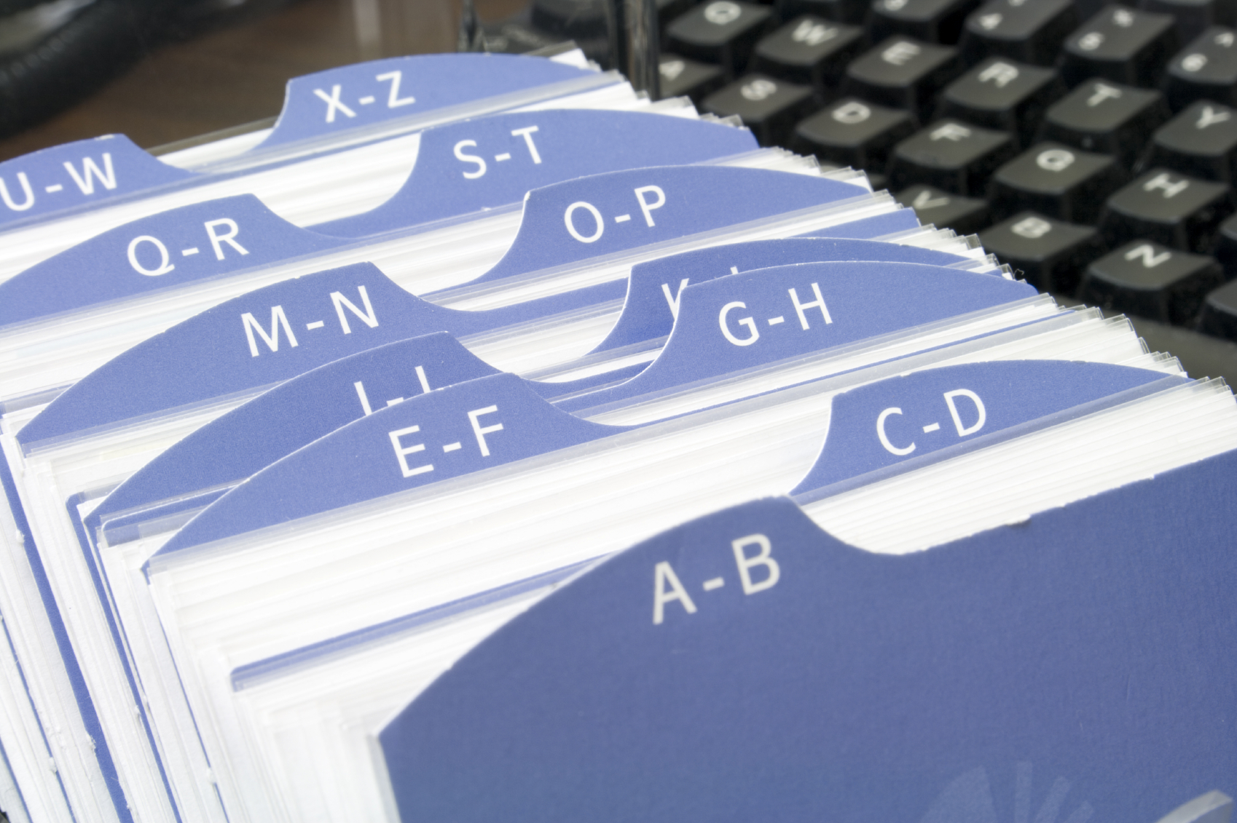
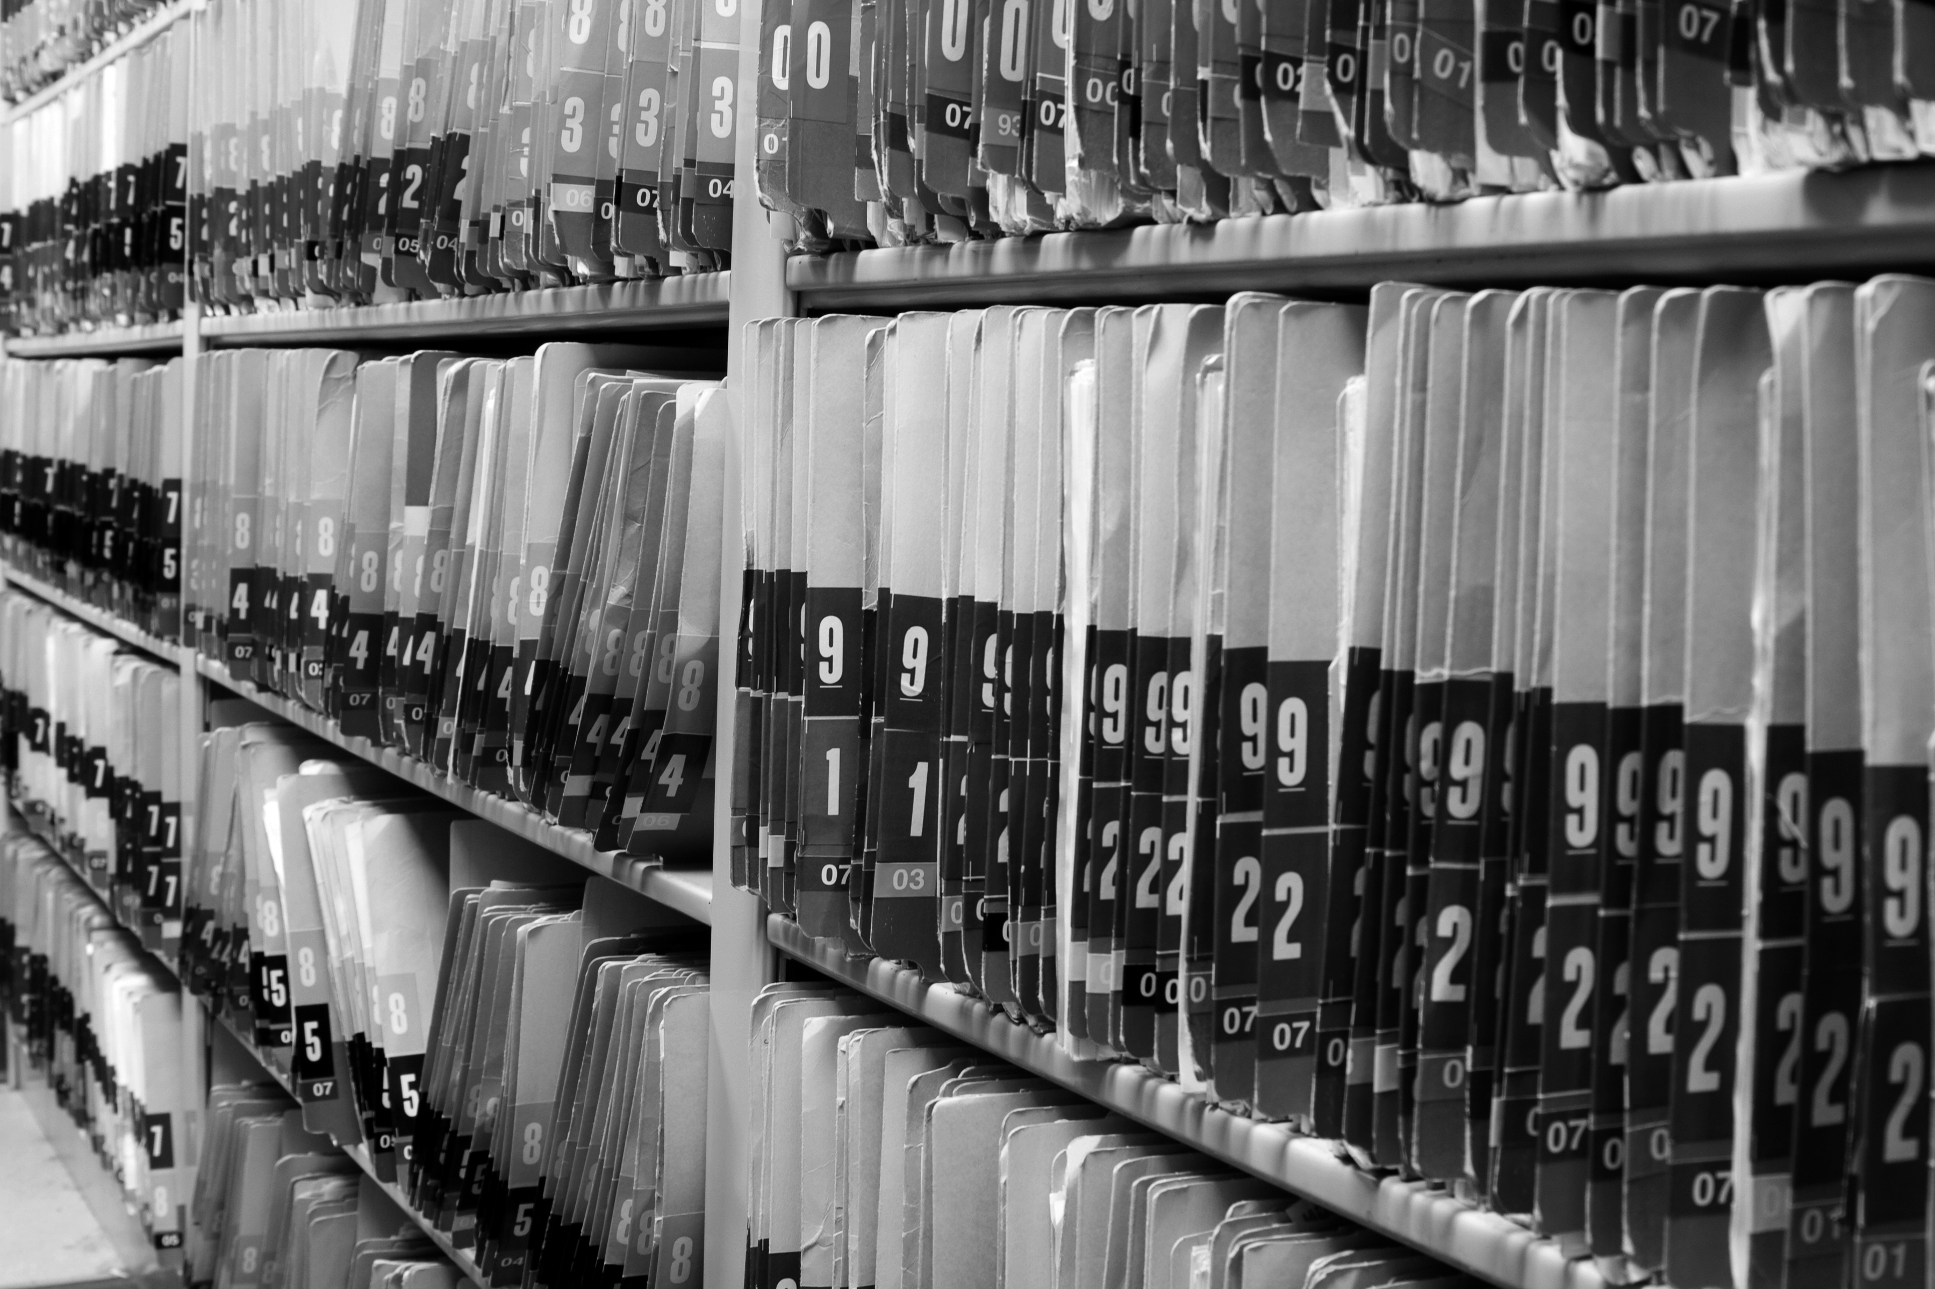

Perform clerical procedures

D1.HRS.CL1.11
D1.HOT.CL1.05
D2.TCC.CL1.09

Trainee Manual





Project Base
William Angliss Institute of TAFE
555 La Trobe Street
Melbourne 3000 Victoria
Telephone: | (03) 9606 2111
Facsimile: | (03) 9670 1330
Acknowledgements
Project Director: | Wayne Crosbie
Chief Writer: | Alan Hickman
Subject Writer: | Birgitta March
Project Manager/Editor: | Alan Maguire
DTP/Production | Daniel Chee, Mai Vu, Jirayu Thangcharoensamut, Kaly Quach

The Association of Southeast Asian Nations (ASEAN) was established on 8 August 1967. The Member States of the Association are Brunei Darussalam, Cambodia, Indonesia, Lao PDR, Malaysia, Myanmar, Philippines, Singapore, Thailand and Viet Nam.
The ASEAN Secretariat is based in Jakarta, Indonesia.
General Information on ASEAN appears online at the ASEAN Website: www.asean.org.
All text is produced by William Angliss Institute of TAFE for the ASEAN Project on “Toolbox Development for Priority Tourism Labour Division”.
This publication is supported by the Australian Government’s aid program through the ASEAN-Australia Development Cooperation Program Phase II (AADCP II).
Copyright: Association of Southeast Asian Nations (ASEAN) 2012.
All rights reserved.
Disclaimer
Every effort has been made to ensure that this publication is free from errors or omissions. However, you should conduct your own enquiries and seek professional advice before relying on any fact, statement or matter contained in this book. The ASEAN Secretariat and William Angliss Institute of TAFE are not responsible for any injury, loss or damage as a result of material included or omitted from this course. Information in this module is current at the time of publication. Time of publication is indicated in the date stamp at the bottom of each page.
Some images appearing in this resource have been purchased from stock photography suppliers Shutterstock and iStockphoto and other third party copyright owners and as such are non-transferable and non-exclusive. Clip arts, font images and illustrations used are from the Microsoft Office Clip Art and Media Library. Some images have been provided by and are the property of William Angliss Institute.
Additional images have been sourced from Flickr and SXC and are used under Creative Commons licence: http://creativecommons.org/licenses/by/2.0/deed.en

File name: TM_Perform_clerical_procedurese_refined.docx





Table of Contents
Introduction to trainee manual 1
Unit descriptor 3
Assessment matrix 5
Glossary 7
Element 1: Process office documents 11
Element 2: Draft correspondence 23
How to fold an envelope 47
Element 3: Maintain document systems 51
Presentation of written work 59
Recommended reading 61
Trainee evaluation sheet 63
Trainee self-assessment checklist 65

Introduction to trainee manual

To the Trainee
Congratulations on joining this course. This Trainee Manual is one part of a ‘toolbox’ which is a resource provided to trainees, trainers and assessors to help you become competent in various areas of your work.
The ‘toolbox’ consists of three elements:
- A Trainee Manual for you to read and study at home or in class
- A Trainer Guide with Power Point slides to help your Trainer explain the content of the training material and provide class activities to help with practice
- An Assessment Manual which provides your Assessor with oral and written questions and other assessment tasks to establish whether or not you have achieved competency.
The first thing you may notice is that this training program and the information you find in the Trainee Manual seems different to the textbooks you have used previously. This is because the method of instruction and examination is different. The method used is called Competency based training (CBT) and Competency based assessment (CBA). CBT and CBA is the training and assessment system chosen by ASEAN (Association of South-East Asian Nations) to train people to work in the tourism and hospitality industry throughout all the ASEAN member states.
What is the CBT and CBA system and why has it been adopted by ASEAN?
CBT is a way of training that concentrates on what a worker can do or is required to do at work. The aim is of the training is to enable trainees to perform tasks and duties at a standard expected by employers. CBT seeks to develop the skills, knowledge and attitudes (or recognise the ones the trainee already possesses) to achieve the required competency standard. ASEAN has adopted the CBT/CBA training system as it is able to produce the type of worker that industry is looking for and this therefore increases trainees chances of obtaining employment.
CBA involves collecting evidence and making a judgement of the extent to which a worker can perform his/her duties at the required competency standard. Where a trainee can already demonstrate a degree of competency, either due to prior training or work experience, a process of ‘Recognition of Prior Learning’ (RPL) is available to trainees to recognise this. Please speak to your trainer about RPL if you think this applies to you.
What is a competency standard?
Competency standards are descriptions of the skills and knowledge required to perform a task or activity at the level of a required standard.
242 competency standards for the tourism and hospitality industries throughout the ASEAN region have been developed to cover all the knowledge, skills and attitudes required to work in the following occupational areas:
- Housekeeping
- Food Production
- Food and Beverage Service
- Front Office
- Travel Agencies
- Tour Operations.
All of these competency standards are available for you to look at. In fact you will find a summary of each one at the beginning of each Trainee Manual under the heading ‘Unit Descriptor’. The unit descriptor describes the content of the unit you will be studying in the Trainee Manual and provides a table of contents which are divided up into ‘Elements’ and ‘Performance Criteria”. An element is a description of one aspect of what has to be achieved in the workplace. The ‘Performance Criteria’ below each element details the level of performance that needs to be demonstrated to be declared competent.
There are other components of the competency standard:
- Unit Title: statement about what is to be done in the workplace
- Unit Number: unique number identifying the particular competency
- Nominal hours: number of classroom or practical hours usually needed to complete the competency. We call them ‘nominal’ hours because they can vary e.g. sometimes it will take an individual less time to complete a unit of competency because he/she has prior knowledge or work experience in that area.
The final heading you will see before you start reading the Trainee Manual is the ‘Assessment Matrix’. Competency based assessment requires trainees to be assessed in at least 2 – 3 different ways, one of which must be practical. This section outlines three ways assessment can be carried out and includes work projects, written questions and oral questions. The matrix is designed to show you which performance criteria will be assessed and how they will be assessed. Your trainer and/or assessor may also use other assessment methods including ‘Observation Checklist’ and ‘Third Party Statement’. An observation checklist is a way of recording how you perform at work and a third party statement is a statement by a supervisor or employer about the degree of competence they believe you have achieved. This can be based on observing your workplace performance, inspecting your work or gaining feedback from fellow workers.
Your trainer and/or assessor may use other methods to assess you such as:
- Journals
- Oral presentations
- Role plays
- Log books
- Group projects
- Practical demonstrations.
Remember your trainer is there to help you succeed and become competent. Please feel free to ask him or her for more explanation of what you have just read and of what is expected from you and best wishes for your future studies and future career in tourism and hospitality.

Unit descriptor
Perform clerical procedures
This unit deals with the skills and knowledge required to Perform clerical procedures in a range of settings within the hotel and travel industries workplace context.
Unit Code:
D1.HRS.CL1.11
D1.HOT.CL1.05
D2.TCC.CL1.09
Nominal Hours:
15 hours

Element 1: Process office documents
Performance Criteria
1.1 Process documents with appropriate office equipment in accordance with enterprise procedures and within designated timelines
1.2 Identify and rectify and/or report malfunctions promptly in accordance with enterprise procedures
1.3 Use office equipment to process documents

Element 2: Draft correspondence
Performance Criteria
2.1 Write text using clear and concise language
2.2 Ensure text is without spelling, punctuation and/or grammatical errors
2.3 Check information for accuracy prior to sending

Element 3: Maintain document systems
Performance Criteria
3.1 File/store documents in accordance with enterprise procedures
3.2 Modify and/or update records management systems in accordance with enterprise procedures

Assessment matrix
Showing mapping of Performance Criteria against Work Projects, Written Questions and Oral Questions
The Assessment Matrix indicates three of the most common assessment activities your Assessor may use to assess your understanding of the content of this manual and your performance - Work Projects, Written Questions and Oral Questions. It also indicates where you can find the subject content related to these assessment activities in the Trainee Manual (i.e. under which element or performance criteria). As explained in the Introduction, however, the assessors are free to choose which assessment activities are most suitable to best capture evidence of competency as they deem appropriate for individual students.
 |  |  | Work Projects | Written Questions | Oral Questions
Element 1: Process office documents
1.1 | Process documents with appropriate office equipment in accordance with enterprise procedures and within designated timelines |  | 1.1-1.3 | 1,2,3,5,6,7
1.2 | Identify and rectify and/or report malfunctions promptly in accordance with enterprise procedures |  | 1.1-1.3 | 8, 9,10
1.3 | Use office equipment to process documents |  | 1.1-1.3 | 11, 12
Element 2: Draft correspondence
2.1 |  | Write text using clear and concise language | 2.1 | 13,14,15,16,17,18,19,  20,21,22
2.2 |  | Ensure text is without spelling, punctuation and/or grammatical errors | 2.2 | 23,24
2.3 |  | Check information for accuracy prior to sending | 2.3 | 25,26, 27
Element 3: Maintain document systems
3.1 | File/store documents in accordance with enterprise procedures |  | 3.1-3.2 | 28
3.2 | Modify and/or update records management systems in accordance with enterprise procedures |  |  | 29,30

Glossary
Term | Explanation
Amendment | A change or improvement in a document.
Back-up system | A system used to store information for security purposes in case the computer system crashes.
Byte | 8 bits
CD-ROM | Compact Disc Read Only Memory, which enables the storage of large amounts of text or data.
CD-R | Compact Disc Recordable
CD-RW | Compact Disc Rewritable
Database | A computer software program used to store and organise a range of records or data.
Data storage | The saving of data to a device such as a floppy disk, CD-ROM, hard drive or a back-up system.
Digital camera | A camera that converts photos into digital images that can be loaded directly onto a computer.
Directories | Tables that contain file information such as name, file, size, time and date of last modification.
DVD | Digital Versatile Disc
Ergonomics | The study of the environment and conditions of work, in order to achieve maximum efficiency and tailoring the physical environment to individual requirements.
File generation | Creation of a new file for information, either on the computer or in a filing cabinet.
Floppy-disk drive | The drive into which a floppy disk may be placed to either save information or read the information stored on it.
Hard drive | The drive within a computer that stores information and enables the computer to run.
Keyboard | An input device with a set of keys used to enter information into a computer.
Log-on | The use of a password to open or access files on a computer system.
Manufacturer’s guidelines | A booklet setting out the manufacturer’s conditions of use for a piece of equipment.
MB | Megabytes
Modem | A piece of equipment that enables the transfer of information from one computer to another via a telephone line or communications cable.
Numerical key pad | Set of number keys on the keyboard.
Printer | A device that prints text or graphics on paper or other media.
Routine maintenance | Ensuring that computers and other equipment are looked after, for example by replacing consumables, clearing paper jams etc.
Scanner | A piece of equipment that copies a document or image directly into a computer.
Spreadsheet | A computer software program used to store and calculate lists of numbers or statistics.
Sub-directories | Directories located within another directory
Technology consumables | Paper, toner, bulbs and other items that must be constantly replaced as they are used or consumed by office equipment.
Zip drive | A high-capacity disk drive, similar to a floppy drive.
Backup | A method of storing files for use in an emergency. The backup medium includes tape, disk or CD
Defrag | Defragmentation is the process of locating the non- contiguous fragments of data into which a computer file may be divided as it is stored on a hard disk, and rearranging the fragments and restoring them into fewer fragments or into the whole file.
Hard Copy | The output from software applications printed and stored on paper.
Inventory | A record of items in stock. This is used to track consumables or to accurately describe devices.
Maintenance | Maintenance refers to rectifying faults and changing settings or components to ensure that equipment continues to work effectively.
Non-routine Maintenance | When a device or its components are serviced to rectify a specific fault. Procedures such as replacing a faulty floppy disk drive or adding extra RAM to a poorly performing computer are some examples of non-routine maintenance.
Print Server | A network node which stores print jobs and then passes them to the printer. This action frees up the network from the slow printer output speed causing network congestion.
Printer Bubble Jet | A printer which uses the process of spraying the ink onto the page by superheating a bubble of ink to eject the spray onto the paper.
Printer Dot Matrix | An impact printer that uses a series of pins to press an inked ribbon onto the paper surface to create a character or image.
Printer Driver | The software the printer uses to interpret the signals from the various applications that have the ability to output hard copy.
Printer Impact | A printer that forms the characters and images on the paper by physical contact. They can be used to make a real time carbon copy.
Printer Ink Jet | A non-impact printer that sprays the ink onto the paper through a series of fine nozzles.

Element 1:
Process office documents

1.1 Process documents with appropriate office equipment in accordance with enterprise procedures and within designated timelines

Unit application
This unit describes the performance outcomes, skills and knowledge required to complete a range of routine office procedures and activities, including writing simple correspondence. As hospitality staff, you will need to perform office procedures, either full-time (for those working in an office environment) or on an occasional basis (for those working in a stock control environment or kitchen).

Introduction
This section identifies the processes that are involved with documentation, and the types of documentation that may be found in hospitality office environments. Processing of documents may include (but is not limited to) recording receipt or sending of documents, mailing (including bulk mailing), photocopying, faxing, e-mailing, collating, binding, and banking.
Office documents may include (but are not limited to) guest mail, customer records, incoming and outgoing correspondence, letters, facsimiles, memos, reports, menus, banquet orders, financial records, invoices, and receipts.
Irrespective of the business you are working in, you will need to follow industry guidelines.

Processing documents
As part of their daily duties, hotel receptionists and certain other staff will have to process documents in accordance with enterprise procedures and within required timelines.

Office equipment
A computer (also referred to as a PC) can be used for various functions e.g. word processing, spreadsheets, databases, business accounting, desktop publishing, accessing the Internet, sending email, playing games, movies, music etc.
A typical standalone computer system is shown below:
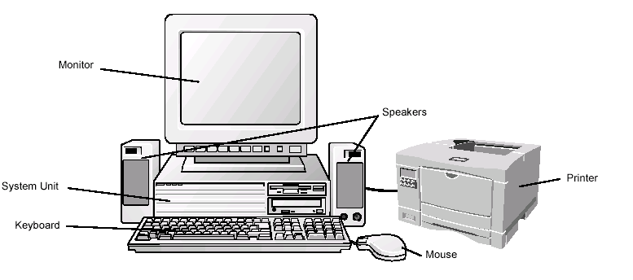

Monitor (or Screen or VDU - Visual Display Unit)
The monitor (or screen) enables the operator to view data (and to alter it before printing it out).
System Unit containing CPU (Central Processing Unit)
The System Unit can contain storage devices such as a hard disk, floppy disk drive and CD ROM drive. A chip (called a Central Processing Unit) within the system unit processes data and relays messages to and from the keyboard, monitor, disk drives and printer.

Keyboard
The computer keyboard has the standard QWERTY layout with extra keys for specific functions. The name comes from the first six letters (keys) appearing in the top left letter row of the keyboard, read left to right: Q-W-E-R-T-Y.

Speakers
The speakers play sound when sound-capable features are accessed on the computer.

Mouse
A mouse is used to select menu options, text and graphics displayed on the monitor.

Printer
A printer is used to print text and graphics onto paper.
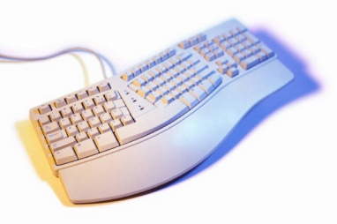

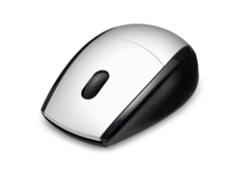


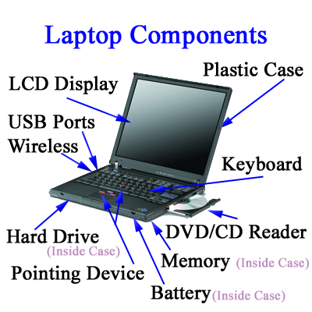
Different Types of Computers

Notebook or Laptop
These are portable computers which are used by people “on the go”. A notebook is similar in size to a standard book. A laptop is larger than a notebook. They are both lightweight, very convenient but are not as fast as a fixed PC, have a shorter battery life and can easily be damaged if not taken care of.

Touch Screen PC
This is a PC that can be held in the hand. A touch screen looks similar to a notebook/laptop monitor, though they can vary in style. A special pen is used to access different menu options on the touch screen. There is no keyboard or mouse.

Palmtops
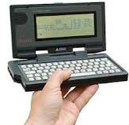
Mini computers are designed to perform basic computer functions and fit in the palm of the hand. Many are used in conjunction with a normal PC. There are different styles available. Two common types are shown. You can transfer data from your PC to the Palmtop as reference or to edit on the go. The palmtop is not as powerful as a PC. Palmtops can be connected to the internet, or to a PC and are useful when travelling to send and receive email.
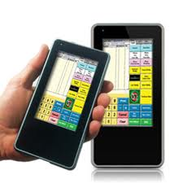
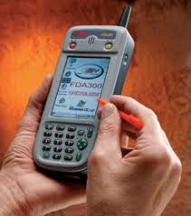

Tablets/I pads and I phones
IPads and android tablets are a combination of a modern smart phone and a laptop computer. Business owners often use tablets to get tasks done on the run, create presentations for meetings and update websites and blogs. They are lightweight, compact and affordable. They can easily be synchronised with your computer when returning to the office.
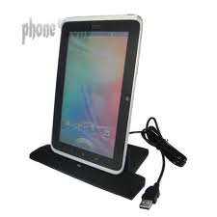
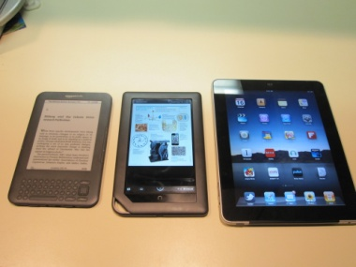

What are hardware and software?

Hardware
The physical components of a computer system - everything that you can touch - are called hardware.

Software
The programs used on a computer are called software. This includes system software (such as Windows, Mac OS etc.) and application software such as Microsoft Word, Microsoft Excel, etc. System software is necessary in order to run a computer and all applications within it.

The System Unit
The System Unit contains the Central Processing Unit (CPU - also referred to as the “processor”), motherboard, memory, video card, sound card, and other internal devices. It also has disk drives for storage media, and ports for external devices.

The Processor
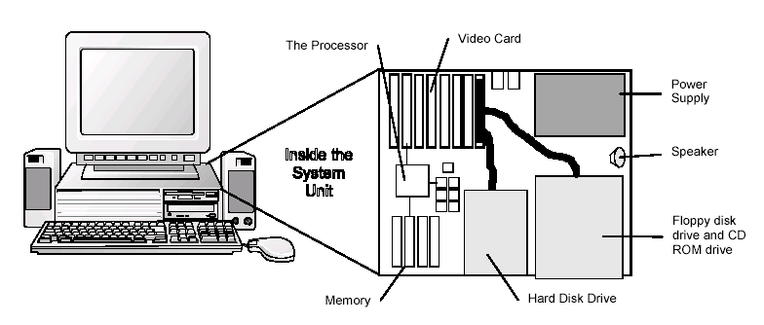
The Central Processing Unit (CPU) is the brain of your computer. It is a “chip” where your computer interprets and processes information. It relays messages to and from the keyboard, monitor, disk and printer.

Hard Disk, Floppy Disk, USB/Memory sticks and CD ROM Drives
Drives are used to store and access data. A hard disk drive is a permanent storage device within your computer. Floppy disk, USB/Memory sticks and CD ROM drives allow you to read data from portable media (CDs, floppy disks and external hard drives).

Video Card
A video card fits inside your computer and determines the resolution (fineness of information) and number of colours your monitor can display. In addition to colour, some video cards allow the display of graphics such as graphs, circles and geometric designs as well as text.

Memory
Your computer has a brain that processes information and a memory that stores the information.
The memory is not a permanent storage place for information. It is only active while your computer is turned on. When your computer is turned off the memory is erased from the computer. This is called Random Access Memory (RAM). To avoid losing your work you should save data on an external hard drive or a disk (i.e. hard disk or floppy disk) for permanent storage.

ROM (Read-Only Memory)
ROM holds data/instructions relating to your computer e.g. ROM may store small programs that can change the configuration of your computer. The data/instructions held within ROM memory cannot be altered. When your computer is turned off the data/instructions within ROM will remain (i.e. will still be there when you next turn your computer on).

RAM (Random Access Memory)
RAM is a set of memory chips that hold data temporarily. This data can be accessed and edited as required. When you turn off your computer the data stored within RAM is lost. When you open a program, it is placed in RAM. When you exit a program, it is removed from RAM. If a machine crashes, all that is in RAM, i.e. programs and/or data, is lost.
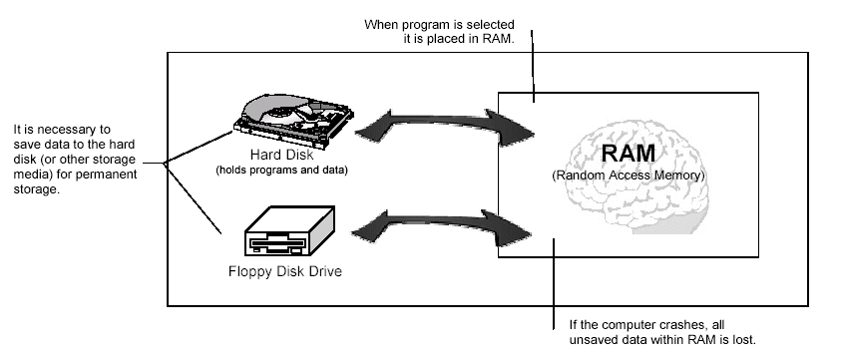
In order to use computer technology correctly, it is important to know the manufacturer’s instructions, as well as the organisation’s policies and procedures regarding:

1.2 Identify and rectify and/or report malfunctions promptly in accordance with enterprise procedures

Introduction
Large hospitality enterprises may have their own IT department who will help you with equipment break down and routine maintenance procedures. However, if you work for a smaller company, it is wise for you to schedule routine maintenance with a contractor.

Preventative Maintenance

Routine or preventative maintenance ensures that the computer equipment will remain in good working order. An example of preventative maintenance on computer equipment is the cleaning of your keyboard, monitor and mouse.
The keyboard can be cleaned by turning the keyboard upside down and gently tapping the bottom of the keyboard. Monitors can be cleaned with a damp cloth. The mouse requires regular maintenance as the tracking ball under the mouse collects dust as it rolls inside the mouse. To clean the mouse, turn it upside, remove the panel, and clean the tracking ball and the rollers inside the mouse.
Remember to keep dust away from the air vents.
Printers require routine maintenance as well. Clearing out paper jams, changing cartridges and cleaning the printer will lengthen the life of your printer. Most printers have a print head cleaning function or you can use a print head cleaning kit. Make sure that you read the manufacturer's instructions before you perform any maintenance.
Consumables like floppy disks, CD's and paper require correct storage to ensure that they will be usable when required. They should be stored in a clean, dry area. To ensure that the moisture content of the paper is kept at an optimum level, paper should be stored in a sealed container. Moist paper tends to curl and jam in the paper path of a printer.

Routine maintenance
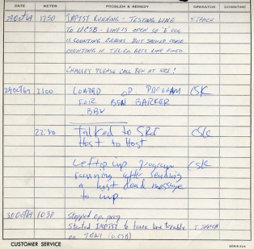
It is important that routine maintenance of business technology is carried out on a regular basis to ensure minimal breakdowns. Equipment should be cleaned regularly by using a damp cloth or other approved cleaning materials. Consumables should be checked to monitor their rate of use, and replaced when needed. Regular servicing by qualified or manufacturer-approved technicians will ensure that all equipment is in the best condition possible to minimise breakdowns.
All employees should receive training to solve common faults, like paper jams, system failures and low ink or toner cartridges. However, more complex problems should be reported immediately to the person in charge of maintenance, to the manufacturer or to the service company. Many companies keep a logbook of service visits.

Technology consumables
In the course of completing work tasks, it is important that you know how to identify and replace technology consumables rather than calling the IT department or appropriate maintenance personnel. Technology consumables are:

To order, you will need to fill out a requisition form or an order form.
Other consumables include floppy disks, the cheapest type of storage media, although they are already obsolete in some countries. The most common type of storage in most countries is a hard drive. Another medium of storing data at low/medium cost is a zip disk which allows you to store up to 750mB of data.

1.3 Use office equipment to process documents

Introduction
In order to select the right technology and software to complete a task, it is important to understand the functions of the office equipment and each type of software. When starting a new job or when a new piece of equipment is purchased, you should be trained in the main functions of the equipment, how to operate the equipment, Occupational Safety and Health issues and routine maintenance.

Selecting the right technology and software
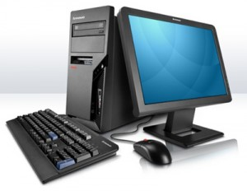
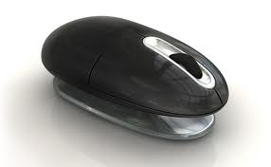
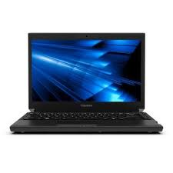

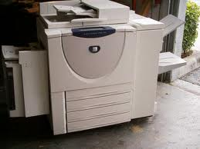
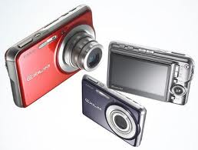
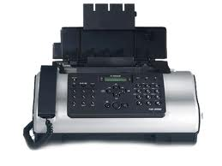

Hardware | Software applications
Computers, including laptops  Digital cameras  Zip drives  Modems  Printer/scanner/photocopier combination  Facsimile  Paging equipment  Calculators  Audio-transcribing machine  Telephone answering machines  External hard drives  Ergonomical mouse. | Email and Internet browsers (Outlook)  Word processing (Microsoft Word)  Spreadsheets (Excel)  Databases (Excel)  Work project  Accounting packages (Myob)  Presentation packages (Ppt)  Manage files (Office Manager).

Work Project 1.1-1.3
It is a requirement of this Unit that you complete Work Projects as advised by your Trainer. You must submit documentation, suitable evidence or other relevant proof of completion of the project to your Trainer by the agreed date.
In groups of 2 you are to set up a new office for an Adventure Tourism Company in Bangkok. Give the company a name. Your company will have 4 employees which will consist of one Director, one Operations Manager, one Operations Assistant and one Marketing Coordinator. Your office will be in an office building, within the central business district. Create a layout which reflects the needs of these 4 employees.
Research needs to be undertaken taking into consideration business technology that you would require including hardware and software, and factors of ergonomics.

PART A – Written Report
- You are to provide a layout of the office space.
- What office equipment including business technology would you select for your new company?
- List 2 benefits and 2 disadvantages of the equipment chosen.
- What is the cost of the equipment? Provide a detailed breakdown.
- How would you maintain this equipment? In-house or outsourced? Explain why you would choose in-house or outsourced?
- Besides Microsoft Office and Summit Pro, name 2 other software packages you would choose for your office.
- List 2 benefits and 2 disadvantages for each of the software packages chosen.
- How would you ensure the set up of the office is ergonomic?

PART B – PowerPoint Presentation
Use the answers from Part A to create a PowerPoint presentation which satisfies the following:
You are to present to the owner of the company what you believe would be the best layout, furnishing, and equipment (hardware and software) for the new Adventure Tourism Company office. You have to sell the benefits of your choices to the owner.

The following must be evident in your PowerPoint presentation:
- Master slide – background used on all slides
- Text layout – 3 different text or content layouts to be used
- Bullets, Tables, Clip art, Charts, Diagrams or Multimedia – use 3 different modes
- Slide animation/transition – used on at least 6 slides
- Minimum 10 slides and maximum 20 slides

- Slides have 5 or less points per slide, legible script with appropriate background, appear professional (less is more) and demonstrate mastery of professional principles
- Less is more. What does this mean in terms of presentation?
- Consider the overall appearance of the PowerPoint very carefully.
A copy of your PowerPoint presentation must be submitted in hardcopy (6 slides per page).

Summary

Process office documents
In this section (Element 1) you have learned how to process documents with appropriate office equipment such as PCs, scanners, pagers, faxes, copiers, etc. Processing of documents must be done in accordance with your company procedures and within the timeline you are given.
This element also describes the maintenance techniques for keeping your computer, keyboard and peripherals clean. Again, it is important you follow your company's guidelines.
Finally, Element 1 explains the difference between hardware and software (the programs).
Element 2 will cover different types of correspondence you may be using in a hospitality environment.

Element 2:
Draft correspondence

2.1 Write text using clear and concise language

Introduction
If you know how to write well, your correspondence will get results. Good correspondence organises relevant information, identifies the writer’s purpose, and presents it in a way that suits the context.

Office documents
In business, certain types of records, forms and modes of correspondence are used daily. To run a business effectively it is important that you are able to utilise the types of office documents as shown below automatically.

Determine audience and purpose
- Who is your audience?
- What is your objective? Is it to enquire, inform, persuade, motivate or to gain visibility?
- What do you want them to do with the information?
- Are they supposed to read the entire document or just part of it?
- Do they need quick points for reference?

Obtain special assistance where appropriate and within budget parameters
If you are writing a complex document, seek advice and information from other personnel and resources.

Conduct research
Basic steps:

Analyse and assess data for relevance prior to incorporation into document, identifying key issues.

Prepare documents
Basic principles

Use a suitable format, structure and style.

Defining, designing and writing the document
Define the scope, purpose and reader needs. Design the structure, content and layout. Write and edit the document.
Spelling:
Dictionaries:
- www.dictionary.com
- www.thefreedictionary.com
- www.thesaurus.com

- www.macquariedictionary.com.au.




Spelling rules:
- Use ‘ise’ not ‘ize’ e.g. we organise (not organize)
- Capitals: at beginning of proper nouns, beginning of sentences. Do not capitalise all your writing as it can be interpreted as yelling
- Numbers: write them as figures (5, 10) except for at the start of sentences
- ‘I before e’ except after c’ rule: this works only when the pronunciation of the word is like a long ‘ee’ for example: piece, niece but exceptions are receive, receipt
- Doubling the consonant: For most words with a short vowel sound, ending with a single consonant, double the consonant when adding a suffix that starts with a vowel, such as er, ed or ing. For example: biggest, hotter, travelling. Exceptions: Some words ending in r, x, w or y are exceptions to the doubling rule:
 | tear + ing | tearing
 | vow + ing | vowing
- If your main word has two consonants at the end, or more than one vowel, don't double the consonant for example: raining, keeper
- Word endings in –ce/-ge: When you want to add a suffix starting with ‘a’ or ‘o’ leave the e in. For example: manageable, noticeable. Exception: prestigious
- Word endings in –ie: When you want to add ing to verbs ending in ie, drop the e and change the i to a y. For example: die – dying, lie – lying, tie – tying
- Words ending in –y after a consonant: When you want to add suffixes such -as, -ed, -es, - er, -eth, -ly, -ness, -ful and -ous to a word ending in y after a consonant, change the y to an i before adding the suffix. For example:
 | eighty + eth | eightieth
 | duty + es | duties
 | lazy + ness | laziness
 | mystery +ous | mysterious
 | beauty + ful | beautiful
- Words ending in –y after a vowel: keep the y when adding suffices such as er, ing or ed. For example:
 | play | playing | played
 | buy | buying | buyer
 | play | playing | player
- Appendices: should be numbered
- Attachments: external documents that should not be included in the body of the document.

Six steps to good writing:

Background Notes
Styles of Letters

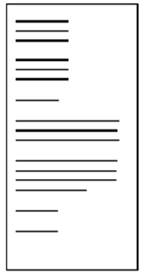
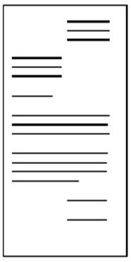

Guidelines for basic business documents
Letterhead

555 La Trobe Street, Melbourne 3000
Ph: 96062111 Fax: 96062114
Email: birgittam@angliss.edu.au

Essential Parts | Optional Parts
Writer’s name and address | Subject line
Date | Attention line
Inside address | Reference initials
Greeting or salutation | Enclosure
Body of the letter | File number
Complimentary close | Sender’s telephone extension
Writer’s signature and job title or designation.

The Complimentary close should match the form of address used in the salutation.
Dear Sir | Dear Ms Pham | Dear Ploy
Yours faithfully | Yours sincerely | Yours sincerely
The Memorandum (Memo)
The main difference between a memo and a letter is that a memo is in-house. It is not sent to people who do not work within the organisation.
Essential Parts | Optional Parts
To  From  Date  Subject | Cc

Routine Letters
Memo
Date: 19 December 2012
To: Hospitality staff
From: Birgitta March
Re: Work placements

You are invited to a meeting to discuss work placements for our hospitality volunteers for the upcoming New Year's Eve function.

Time: 10 am
Date: 22 December 2012
Where: Meeting room B245, level 3
R.S.V.P: By 21 December 2012
Email: birgittam@angliss.edu.au

I hope you can all attend.
The routine correspondence can be planned in three steps.
Opening Paragraph | Middle Paragraphs | Ending Paragraph
Refer to the communication they sent to you | Provide complete information | Include a goodwill close

- Most routine business letters begin by referring to previous correspondence:
- Here is the information you asked for in your letter of 12 November.
- In your letter of 9 June, you asked for...
- In reply to your letter of 8 August...
Or your letter may be in response to a telephone call or a in-person conversation. Then you might write:
- Following our conversation this morning...
- Your telephone call this morning reminded me that...
- Providing complete information means giving all the necessary details.
This involves trying to answer any possible questions that the reader may want to ask. A bulletin or brochure is a useful way to minimise detail in letters.
- We close our letter with a note of goodwill, to avoid sounding abrupt.
Good News Letters
Opening Paragraph | Middle Paragraphs | Ending Paragraph
Write the good news | Provide relevant detail | Repeat the good news

The opening paragraph can begin with the good news and remove any uncertainty the reader may have about our response to their situation:
- Although the warranty on your heater ended six months ago, we have decided to replace it without further charge
- We overestimated the costs of repairs to your roof. The account will be $700.00 less than we anticipated.
The middle paragraphs of our correspondence provide the reader with detailed explanation of what has taken place.
The final paragraph in the letter can again refer to the good news. Please telephone our office to make a suitable time for our plumber to fit your new heater. Our cheque for seven hundred dollars is enclosed.
This pattern of writing a good news letter is well balanced and leaves our reader with positive thoughts about our product and our company.

Writing Good News or Neutral Letters
The content of different types of positive or neutral letters will vary. Listed below are four different types of good news letter.
- AN INQUIRY | - A REQUEST
A letter of inquiry asks others to share information and ideas | A letter of request seeks a specific action eg. A purchase order
- AN AKNOWLEDGMENT | - A LETTER OF INTRODUCTION
A letter of acknowledgment acknowledges requests for information, confirms orders, supplies information and thanks the reader. | A letter of introduction aims to maintain contact and create goodwill and the opportunity for future sales or business.
LETTER WRITING STRATEGIES – Good News or Neutral Letters
- Inquiry
- Identify the inquiry in the subject line
- Open with the inquiry and a short background if necessary
- Indicate the need for the receiver to respond
- Close in a courteous and friendly manner
- Request
- Identify the request in the subject line
- If you chose to omit the subject line, identify the request and give a brief reason or background for the request in the opening paragraph
- Ask for a specific response to the request
- Close courteously to maintain goodwill
- Letter of acknowledgment
- Start with the acknowledgement
- Say ‘yes’ clearly when relevant
- Supply any necessary information or details
- Close courteously to maintain goodwill
- Letter of introduction
- Use the subject line to catch the reader’s interest
- Open with a reason for the introduction and aim to catch the reader’s attention and interest
- Use details and information in the middle paragraphs to create a desire to read further

- Close by saying what you can do for the reader and what you want the reader to do
- Letter or request (good news letter) using modified block layout with indented paragraphs.

PARADISE EVENTS
971 Ploenchit Road
Pathumwan, THAILAND 10330
Ph: 1800-578-252

4 February 2012
Aat Yodsuwan
H & R Publishing Group Pty Ltd
1022 Phetchburi Road
Bangkok THAILAND 10400

Dear Aat,
Re: Order for Brochure for Paradise Events
I would like to place an order for the printing of the advertising brochure for Paradise Events.
Our advertising is booked on Order No. 5565, customer No 332345. I have enclosed a proof for the printer to assess the colours. Please return the proofs after the print run.
I would appreciate your prompt handling of this order so that we may have the brochures by 1 March.
Please contact me if you have any questions. I am most happy with your previous work and look forward to receiving this order.
Yours sincerely
Apichart Kasem
Manager

Order of information

Subject Line
Identify the request
Background details

Specific response

Courteous close

Bad News Letters
The bad news letter can be planned in three steps.
Opening Paragraph | Middle Paragraphs | Ending Paragraph
Allude to the situation with a neutral comment | Give details and reasons.  State the bad news.  Provide workable alternatives. | Close with a neutral or positive statement.

- We start with a statement of fact which is a neutral statement concerning the situation:
- The heating unit that you returned has been checked by our laboratory
- The cost of the repairs to your roof which we originally estimated at $8000 can now be compared with the actual costs of the materials.
- We must provide details and reasons before we fully reveal the bad news. We must explain some of the factors that have influenced our decision.
- In the process of installation your heater has received some damage which has stopped the flow of water into the unit. Broken pipes may result from improper positioning during installation or from mistreatment on the pipes once they are in place.
In that same paragraph we then state the bad news.
- Consequently we cannot provide the requested coverage at this time.
- Close with a neutral or positive statement.
- We can recommend an excellent tradesman to correctly install one of our new heaters
- Thank you for thinking of us for your heating needs.
Do not close your letter by asking them if you can help them in some other way, since you were not able to help them this time. Avoid the urge to apologise to them in the final paragraph. You have done all that is possible for you to do, so you do not need to apologise.
Writing Bad News Letters
Listed below are four different types of bad news letters and guidelines for writing them.
- ORDER REFUSAL | - SAYING ’NO’ TO A REQUEST FOR CREDIT
An order refusal declines a request | A credit refusal rejects a request for credit
3. REFUSING AN ADJUSTMENT | 4. DECLINING INVITATIONS AND REQUESTS FOR FAVOUR
An adjustment refusal is a request to change, replace or adjust a transaction that has already taken place | An invitation or request refusal

LETTER WRITING STRATEGIES – Bad News Letters:
  - Order refusal
- Start with an acknowledgment of the order
- Give an explanation with reasons that lead to the refusal
- State the refusal
- Close with a positive, courteous paragraph which expresses interest in a continuing relationship with the customer in the future.
  - SAYING ’NO’ TO A REQUEST FOR CREDIT
- Start with a neutral opening or buffer paragraph
- Give an explanation of the factors considered in the decision
- State the refusal clearly and courteously
- Close with a positive, courteous paragraph which invites the receiver to contact your organisation in the future.
  - REFUSING AN ADJUSTMENT
- Start with a buffer paragraph which acknowledges the request for the adjustment
- Give a positive explanation of the reasons for the decision
- State the refusal courteously
- Close with positive language in an attempt to maintain the customer’s goodwill.
  - DECLINING INVITATIONS AND REQUESTS FOR FAVOUR
- Start with a neutral buffer, preferably an appreciation of the invitation or request
- Give an explanation and reasons
- State the refusal clearly, courteously and tactfully
- Close with a positive paragraph which expresses interest in the other person or organisation.

Yen Recruitment Hai Ba Trung Street
Hanoi, VIETNAM 102222-153343
Ph: (03) 9822 3456
yen@yenrecruitment.com

27 February 2012

Ms Dung Pham
2 Cong Quynh St., District 1
Hanoi, VIETNAM 102222-153589

Dear Dung,

Thank you for the time you gave up to attend an interview with Bao Bui recently. Bao enjoyed meeting with you and hopes you found the discussion informative.

We can, of course, only invite a proportion of the candidates we meet to the second interviews. Consequently, our evaluations are made using a number of key criteria. The difference between those selected for follow-up and those who miss out is sometimes marginal. However, with a set number of positions available we hope you will understand the difficulty in making final decisions.

While your application has been given serious consideration, we regret to advise that, on this occasion, we will not be offering you a second interview.

We appreciate your interest in our firm and wish you every success in your future career.

Yours sincerely,

Yen Truong
Personnel Officer

Effective bad news letter refusing employment (full block layout)
Order of information

Neutral buffer
Explanation

Refusal
Positive close

Background Notes
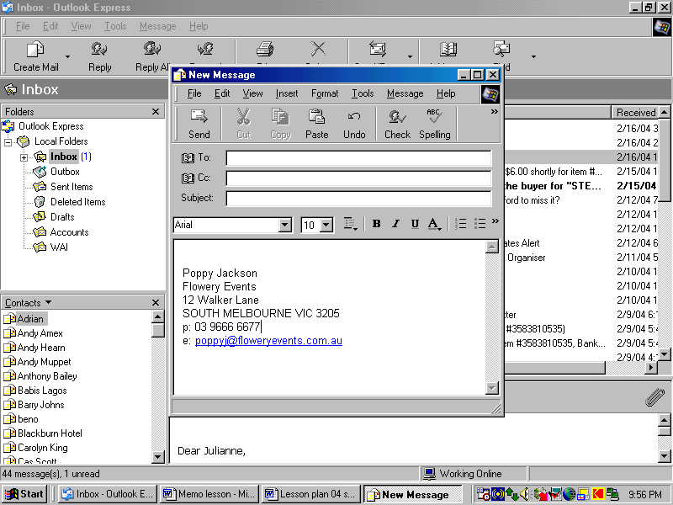
Add a Signature to Email in Microsoft Outlook
- Open Microsoft Outlook. This can be done from a shortcut on the desktop, from the Start menu or from the Quick Launch Bar if you have enabled it on the taskbar
- Click the "Tools" menu on the menu bar
- Click "Options"
- Click on the "General" tab
- Click the "Email Options" link
- Click the "Email Signatures" tab
- Enter the title of the signature in the title box. The title of the signature is important, especially if you plan on using more than one signature for your emails (one for personal emails, one for professional, one for fun, etc.)
- Fill in the body of the signature in the text field titled "Create your email signature." Here you can include plain text, as well as pictures, animated images (in the form of HTML links) and anything else that can be displayed in a HTML enabled email server
- Click "Add" to finalize the signature
- Click the "New" button to create another signature. You can simply repeat steps 7, 8 and 9 to complete the process. You may continue to add signatures until you are done.
  - Source: http://www.ehow.com/how_2048574_add-signature-email.html#ixzz1Ts6EJKYE
Work project 2.1
It is a requirement of this Unit you complete Work Projects as advised by your Trainer. You must submit documentation, suitable evidence or other relevant proof of completion of the project to your Trainer by the agreed date.
- You are the owner of a very busy Bangkok restaurant. Business has been good and to reward your staff for their hard work, you are organising a party on 20 June 2012 at 8 pm. Please type up a memo to your staff advising them of the party and inviting them to bring their partner and/or family. You want to hold the party in your own apartment above the restaurant. For catering purposes, you need them to respond by 14 June.
Please ensure you:
- Design a professional memo layout
- Use correct memo spacing
- Do a spell check and grammar check.
Save your memo on your USB under the new folder "Homework". Name it "Memo_20June2012".
Email
Email is an inexpensive, rapid and useful tool. Rules are:
- Keep to one subject per email

- One screen
- Focus: Who? Why? What?
- Avoid ‘send all’ where possible
- To: recipient - action
- CC: copy - information only
- BCC: blind copy – cannot be seen by everyone
- Attachments: no novelty attachments in business emails
- Check for viruses
- Avoid emoticons e.g.
- Remember that emails make 4 copies: 1 on your PC, one of the receiver’s PC, one on your server and one on the receiver’s server.

2.2 Ensure text is without spelling, punctuation and/or grammatical errors

Introduction
Good workplace writing results from thoughtful planning, writing in plain English and careful editing. Each stage is part of the writing process.
At the planning stage, take time to identify your purpose, consider your receiver, decide what you want to say and put this in a logical sequence.
At the editing stage check your work for accuracy and completeness and make sure that your writing is logical, clear and concise.
At the writing stage, your tools are words, sentences, paragraphs and layout. Make sure you convey your meaning concisely and courteously. The receiver of business correspondence wants to understand what should happen, why it should happen and how to go about making it happen.
The main purpose when writing in plain English is to get the message across.

Types of Documentation
The rule of "7 Cs"
Most businesses have standard formats for the layout and style of the documents they produce. These are called 'templates'.
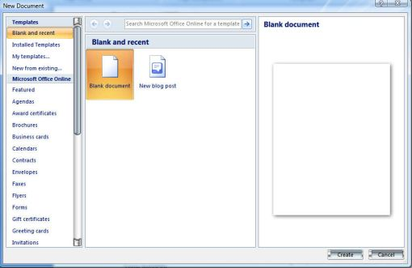

When writing Business Correspondence we generally consider the rule of the “7 Cs ". This means that all of your work should be:
- Clear - able to be understood in one reading by the recipient (time = money)
- Concise - conveying what has to be stated with a minimum of words, sentences and paragraphs
- Complete - all of the information necessary to understand the correspondence is passed on
- Correct - all of the information conveyed is accurate.
- Courteous - your tone is always polite as you are representing your organization and wish to create goodwill
- Clean - this means that there are no coffee stains, liquid paper, or crossing out on your correspondence. It also means that your work is not cluttered and there is plenty of white space so that the document looks appealing and professional
- Checked - this means your work has been examined for spelling mistakes, grammatical mistakes, format and layout and found to be mistake-free.
Omit unnecessary words
Too wordy | Better option
As of now | Now
At a price of $20 | $20
We can supply them in the following colours: blue, green and yellow | We can supply them in blue, green and yellow
We seldom ever make this mistake | We seldom make this mistake
In my personal opinion | In my opinion
In the event that | If
During the month of April | During April
For the reason that | Because
During which time | While
We are of the opinion | We believe
At the present time | Now
In the majority of instances | Mostly
According to our records | We find
On a regular basis | Regularly
He is sorry for | He regrets
He has no confidence in | He doubts
She is in accord with | She agrees
In the near future | Soon

Background Notes
Punctuation Marks serve to indicate the structure and organisation of writing, as well as intonation and pauses to be observed when reading it aloud
. | FULL STOP | Commonly placed at the end of several different types of sentences in English and many other languages.
, | COMMA | Used in many contexts, principally for separating things
: | COLON | A colon informs the reader that what follows proves, clarifies, explains, or simply enumerates elements of what is referred to before.
; | SEMICOLON | The mark to separate words opposed in meaning and to mark off interdependent statements.[
‘ | SINGLE  QUOTATION MARK | Used in pairs to set off speech, a quotation, a phrase or a word.  Also known as inverted comma.
“ ” | DOUBLE QUOTATION MARK | Used in pairs to set off speech, a quotation, a phrase or a word.  Also known as an inverted comma.
( ) | BRACKETS | To set apart or interject text within other text  Four main types of brackets:  Round brackets or parentheses: ( )  Square brackets or box brackets: [ ]  Curly brackets: { }  Angle brackets: ⟨ ⟩
! | EXCLAMATION MARK | It is usually used after an interjection or exclamation to indicate strong feelings or high volume, and generally marks the end of a sentence.
? | QUESTION MARK | Also known as an interrogation point, question point or query is a punctuation mark that replaces the full stop at the end of an interrogative sentence.

Source: Wikipedia Encyclopaedia

Various techniques
- Change page size and orientation
- Change page margins
- Add/delete columns
- Formatting including Alignment and line spacing, font size, indents, font colours, outside borders, bullets, numbering
- Copying, cutting and pasting
- Inserting page breaks and section breaks

- Inserting or changing headers and footers
- Inserting page numbers
- Adding styles
- Inserting and formatting tables
- Saving documents
- Inserting images and graphics/clip art
- Inserting smart art and shapes
- Check spelling and grammar
- Attaching documents
- Saving and naming documents
- Copying files/folders
- Setting up the correct printer.

Work project 2.2
The task for this section requires you to complete the following:
Type the attached letter on a page as it appears noting the following instructions:
- Use WordArt and clip art to create the letterhead of the attached letter
- The web address is in Ariel point 11 size, the remainder of the letter is in Ariel 12 point
- The list is to be numbered and indented appropriately
- Insert a footer with your name on the right
- Save the document to your USB as Thai Eco Tours_name_date.


P.O. Box 7845
Bangkok 10400, Thailand
www.thai_ecotours.com
Tel: +66 72 123 456

20 December, 2012
Mrs. Birgitta March
William Angliss Institute of TAFE
555 La Trobe Street
Melbourne, Vic. 3000
Australia
Dear Mrs. March,
We are pleased to advise your trip details for your upcoming eco tour in Thailand. Your itinerary is as follows:
Day 1-3: Bangkok
Day 4-7: Chiang Mai to hilltribe (trek)
Day 8-12: Khao Sok & Chieow Laan Lake (jungle safari)
Day 13-16: Phuket (beach holiday)
Day 17: International flight
As our enclosed brochure outlines, the eco trip we propose includes all meals, overnight stays in eco lodges, transport and local guide. The total price is $2,000.
If you require further information, please do not hesitate to call me on the above number or email me on yochit@thai_ecotours.com.

We look forward to hearing from you.

Yours sincerely,
Yochit Rinjan
Travel Manager
* Enclosed: travel brochure

2.3 Check information for accuracy prior to sending

Introduction
The first thing you must do when you have completed your draft document is to do a spell check. However, beware that spell checkers are not totally accurate. You may need a dictionary (see element 2.1). You will need to add new words when you are sure you have spelled them correctly.

Running a spell check
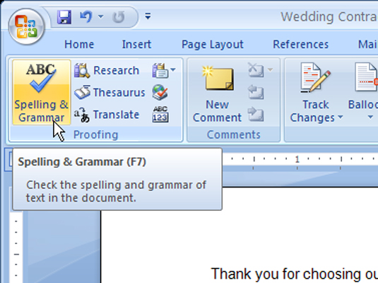
Step 1: On the Review tab, click the Spelling & Grammar button.
Kitchen inventory as at

Step 2: choose correct word
Step 3: add new word to your dictionary, where appropriate
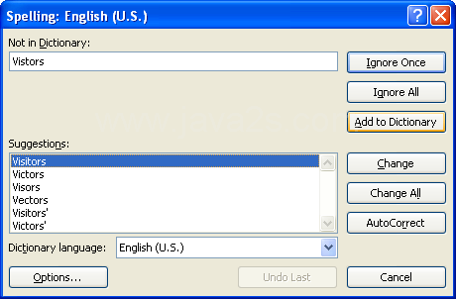

How to fold an envelope
DL Envelope
110mm x 220mm - standard, business sized envelope. Designed to fit 1/3 of an A4 sheet.(Post Office Preferred.) Fold the letter twice so that it is creased to make thirds. This will fit easily in a standard envelope, and it is easy to unfold.
The address of the recipient is in the middle of the envelope, beginning approximately halfway down. (Be sure it is mostly below the stamp, or it may get covered over by the cancellation.)
The return address is in the upper left-hand corner. This is not necessary to type in if the stationery is pre-printed with the return address.
If you are using business envelopes with a window, fold the letter so that the inside address shows through the window.
Some correspondents include an attention line near the lower left corner for routing purposes. This is normally part of the main address unless space is a factor. It may be a department or a person's name. For example: Attn. : returns dept.
To type an envelope in Microsoft Word, go to ‘mailings’ tab, ‘create envelope’, then enter the delivery address and return address details.
Full name
Return address 1
Return address 2
Company name (if applicable)
Attn.: name/department
Recipient address 1
Recipient address 2
Postcode
How to fold a standard letter
A business letter is folded twice into horizontal thirds and placed into an envelope.
This insures a little privacy in the letter. The letter is also easy to unfold after opening the envelope.
The following diagram shows how a letter is normally folded. This type of fold is used regardless of letter style:
- Begin with the first page of the letter facing towards you.
- Crease the letter along a fold one-third from the bottom. Fold the letter up to a point one-third from the top, covering the writing on the letter.
- Make a second horizontal crease one-third from the top of the letter where the bottom of the letter had been folded to.
- Tuck the bottom into this crease and fold the top over it. The letter will be folded into thirds. It will fit any standard envelope.
If the letter needs to have the address face out an envelope window, make the second fold in the same location but opposite direction. The letter will then be folded in a Z shape and the address can be positioned to face out the window of the envelope.
 |  | 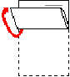

Work Project 2.3
It is a requirement of this Unit that you complete Work Projects as advised by your Trainer. You must submit documentation, suitable evidence or other relevant proof of completion of the project to your Trainer by the agreed date.
You are the owner of a charter bus company, VLines, in 3345 Truong Street, Vientiane, Laos. Due to the recent global economic downturn, internal tourism numbers have dropped by 50%.
Write a memo advising all staff of an upcoming meeting to discuss repercussions of this downturn
Write a letter to your coach captains advising them of the meeting on July 1, 2012 at 2 pm in your office. Firstly consider the type of letter (routine letter, good news letter, bad news letter). Secondly, ensure you follow the correct steps. Explain why you have chosen this type of letter
Type out an envelope using the ‘mailings’ tab.
Spelling, grammar and sentence construction must be correct. Ensure that there is sufficient information in the document so that all the recipients understand what will be expected of them in terms of attendance.

Summary

Draft correspondence
In this section (Element 2), you have learned the different types of correspondence you may be using in a hospitality environment.
When drafting correspondence, it is important to determine who your audience is and to have a clear objective. Plan your paragraphs, research and follow the basic steps of collating, writing, editing and presenting. Draft your document into three clear sections: introduction, body and summary.
You have also learned the main difference between a memo and letter and discussed various styles of letters.
Remember the 7 C's rule.
Remember to use the various techniques to edit a document as per the class demonstration and work project. And finally, always remember to run a spell check and add new words to your dictionary.
In the next section (Element 3), you will learn how to maintain document systems.

Element 3:
Maintain document systems

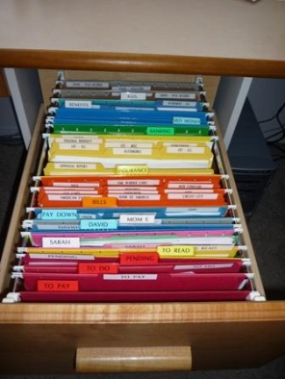
3.1 File/store documents in accordance with enterprise procedures

Introduction
It is important that you learn to file/store your documents either electronically or in hard copy according to the organisation’s guidelines.

Storage of data
Most data is stored on a computer’s hard drive. It is important to understand a computer’s file management system in order to save work in the right place. Data is stored in folders (or directories) and sub-folders (or sub-directories), similar to a paper-based filing cabinet.
Below are examples of how Microsoft Windows Explorer organises its directory:
This is a section of Windows Explorer showing how the files are organised into a multi-level filing system.  The “+” signs to the left of some folders indicates that there are further sub-folders located in these folders. | 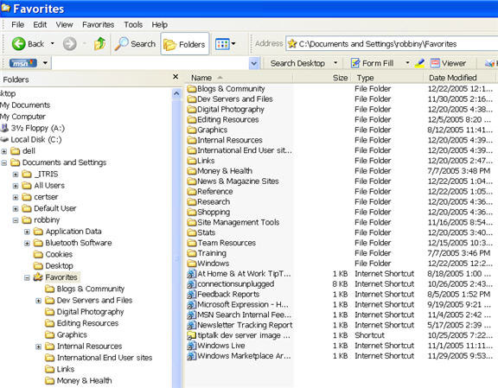
By clicking on a folder with a “+” sign to its left, all the sub-folders within that folder can be seen.  A “-” sign to the left of a folder indicates that all sub-folders are showing (as per the favourite’s example). | 

Other than on the hard drive, data may also be stored on:
- USB memory sticks
- External hard drives: important in case of computer failure to safeguard large amounts of information
- Floppy disks or CD Roms: remember that a limited amount of information can be stored here, so it is a good idea to compress the file to accommodate large amounts of data. They are becoming obsolete, in favour of the above.


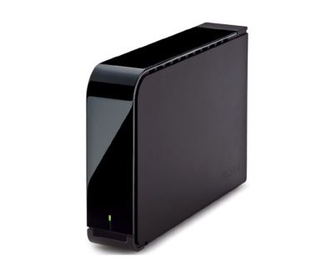

3.2 Modify and/or update records management systems in accordance with enterprise procedures

Introduction
Traditionally, companies have been focused on updating their physical records. However, increasingly, they need to focus on updating and standardising their electronic information. It is important to take the time and get the resources to get this right, in accordance with industry and enterprise practices.

Various filing techniques

Organisation of information
The most common types of classification for records and information are alphabetic, numeric, alpha-numeric, geographic, subject, keyword and chronological
Alphabetical
The most commonly used method of filing, the alphabetical system, places files in alphabetical order according to the customer or business name e.g. the telephone book. There are a number of rules to remember when using the alphabetic system.
- Disregard ‘joining’ words and titles such as “and”, “the”, “&”, “Mr”, “Sir”, “Dr”, “Miss” etc
- Hyphenated or compound names are treated as one word e.g. Jones-Smythe and van der Lynden are both indexed as one word
- Initials come before names (in filing ‘nothing comes before something’), e.g. B. Thompson would be filed ahead of Brian Thompson
- Company names are treated in the order they are written, except if they contain a family name e.g. both Grace Bros and Robert E. Grace & Sons are filed under ‘Grace’, but Robert & Hickey would be filed under ‘Robert’
- Abbreviations are treated as if the word was written in full
- St. is indexed as Saint, Ltd. as Limited. This means that St. and Saint entries are treated as if spelt the same way, as are Mac and Mc
- Numbers which are part of a business or company name are regarded as though spelled e.g. 24-7 is indexed as twenty-four seven.
Numerical
Each file or piece of information is filed in number order, from lowest to highest, according to the number on the document (for example, invoice number) or the customer number.
Geographical
Information is indexed alphabetically according to geographical location. States/Provinces are indexed first, followed by the city, town or suburb, then other appropriate information e.g. customer name.

Subject
Records are sorted according to the subject matter and filed alphabetically. This allows information on the one topic, or subject, to be easily located.
Key word
A particular word is used as the subject classification and specific descriptors are also allocated to further classify the information. Keyword systems are usually used in large organisations where the keywords are specifically designated.
Chronological
Chronological filing is used in conjunction with other filing methods and involves sorting records according to their date. In a client file for example, correspondence would be filed with most recent on top. Copies of Purchase Orders would be filed with the most recently sent order on top.

Retrieving documents
Documents can be opened from a software program (e.g. Word) or a file management program (e.g. Windows Explorer).

If a document cannot be found, it is possible to follow these basic steps:
- go to Computer icon on your desktop OR go to “Start”
- “search”
- “all files and folders”
- Fill in the information that is known, as shown below.
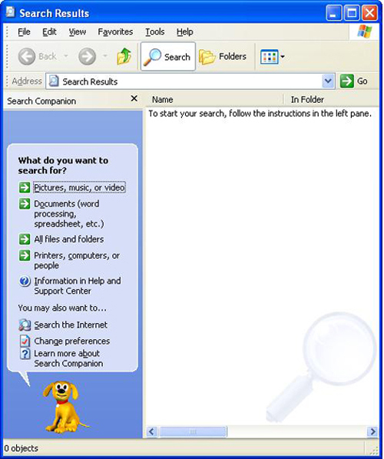

Deleting temporary files
Temporary files are backup files that are automatically created by the computer in case a document is lost.
Temporary files can be found on the C drive in the following 3 locations:
- C:\Temp
- C:\Windows\Temp
- C:\Windows\Temporay internet files.
To delete these files:
- Open Windows Explorer and go to the specified drive and folder e.g. C:\Temp
- Click on a file on the right of the screen and press Ctrl A (select all). Click on the delete button or press the Delete key, and click on Yes. If you receive any further messages about files, click on No.
- Repeat the above steps for each of the temp folders listed above.

Emptying the Recycle Bin
- Double click on the Recycle Bin icon on the desktop (or select recycle bin from within Windows Explorer.)
- Choose [File] Empty Recycle Bin, then click on Yes.
- Close the Recycle Bin.

What to Do if Things Don’t Work
Are all the leads connected properly? Check the following:
- Power lead
- Monitor lead
- Mouse connection
- Hard drive connections.
Make sure that the computer is turned off first!
What if it freezes?
- Don’t keep clicking
- Don’t hit it
- Do wait for a few moments to see if it catches up with your flying fingers.
- If not – then hit Alt+Ctrl+Del. Or the restart button (but only as a last resort.)
- This will re-boot the system for you, but you’ll probably lose any information you had not saved
- That’s why you should be constantly saving your work as you go along.

Background Notes
Forms of paper based storage
Filing cabinets | 3-drawer, 4-drawer, 2-drawer
Flat boxes | Flat box file, horizontal plan file
Lever arches | Binder
Suspension folders | Hanging files
Shelving | Lateral cabinets, compactus
Other | Trolley, spike file, rotary file, concertina file

Forms of electronic storage
Database | For example, using Microsoft Access or Works
Computer files | For example, using Microsoft Word or Excel files on hard or floppy disk
Email | For example Hotmail or Yahoo

Work Project 3.1-3.2
It is a requirement of this Unit that you complete Work Projects as advised by your Trainer. You must submit documentation, suitable evidence or other relevant proof of completion of the project to your Trainer by the agreed date.
Save all work projects in a newly created folder “Work projects”. Label them according to their number ie work project 1.1-1.3, work project 2.1, work project 2.2, work project 2.3, work project 3.1-3.2
Save all answers to the written questions in a newly created folder “Answers_first name_last name”. File them as per the filing techniques in element 3.2 and explain why you have chosen this style of filing
Compose a new message to your trainer, using Outlook Express and attach both folders.

Summary

Maintain document systems
In this section (Element 3), you have learned how to file and store documents in accordance with enterprise procedures and guidelines in order to save work in the right place.
Companies streamline their filing systems in order to manage their ever growing amount of data effectively and to make their processes/policies as user-friendly as possible. In this way, every employee can find files easily. However, you have learned to search for a document where you cannot locate a file or folder.
It is important to know how to delete files, empty your recycling bin on a regular basis or in accordance with enterprise procedures.

Presentation of written work

1. Introduction
It is important for students to present carefully prepared written work. Written presentation in industry must be professional in appearance and accurate in content. If students develop good writing skills whilst studying, they are able to easily transfer those skills to the workplace.

2. Style
Students should write in a style that is simple and concise. Short sentences and paragraphs are easier to read and understand. It helps to write a plan and at least one draft of the written work so that the final product will be well organized. The points presented will then follow a logical sequence and be relevant. Students should frequently refer to the question asked, to keep ‘on track’. Teachers recognize and are critical of work that does not answer the question, or is ‘padded’ with irrelevant material. In summary, remember to:
- Plan ahead
- Be clear and concise
- Answer the question
- Proofread the final draft.

3. Presenting Written Work
Types of written work
Students may be asked to write:
- Short and long reports
- Essays
- Records of interviews
- Questionnaires
- Business letters
- Resumes.
Format

All written work should be presented on A4 paper, single-sided with a left-hand margin. If work is word-processed, one-and-a-half or double spacing should be used. Handwritten work must be legible and should also be well spaced to allow for ease of reading. New paragraphs should not be indented but should be separated by a space. Pages must be numbered. If headings are also to be numbered, students should use a logical and sequential system of numbering.
Cover Sheet
All written work should be submitted with a cover sheet stapled to the front that contains:
- The student’s name and student number
- The name of the class/unit
- The due date of the work
- The title of the work
- The teacher’s name
- A signed declaration that the work does not involve plagiarism.
Keeping a Copy
Students must keep a copy of the written work in case it is lost. This rarely happens but it can be disastrous if a copy has not been kept.
Inclusive language
This means language that includes every section of the population. For instance, if a student were to write ‘A nurse is responsible for the patients in her care at all times’ it would be implying that all nurses are female and would be excluding male nurses.
Examples of appropriate language are shown on the right:
Mankind | Humankind
Barman/maid | Bar attendant
Host/hostess | Host
Waiter/waitress | Waiter or waiting staff

Recommended reading
- http://www.java2s.com/Tutorial/Microsoft-Office-Word-2007/CatalogMicrosoft-Office-Word-2007.htm

Trainee evaluation sheet

Perform clerical procedures
The following statements are about the competency you have just completed.
Please tick the appropriate box | Agree | Don’t Know | Do Not Agree | Does Not Apply
There was too much in this competency to cover without rushing.
Most of the competency seemed relevant to me.
The competency was at the right level for me.
I got enough help from my trainer.
The amount of activities was sufficient.
The competency allowed me to use my own initiative.
My training was well-organized.
My trainer had time to answer my questions.
I understood how I was going to be assessed.
I was given enough time to practice.
My trainer feedback was useful.
Enough equipment was available and it worked well.
The activities were too hard for me.
The best things about this unit were:

The worst things about this unit were:

The things you should change in this unit are:

Trainee self-assessment checklist
As an indicator to your Trainer/Assessor of your readiness for assessment in this unit please complete the following and hand to your Trainer/Assessor.

Perform clerical procedures
 |  | Yes | No*
Element 1: Process office documents
1.1 | Process documents with appropriate office equipment in accordance with enterprise procedures and within designated timelines
1.2 | Identify and rectify and/or report malfunctions promptly in accordance with enterprise procedures
1.3 | Use office equipment to process documents
Element 2: Draft correspondence
2.1 | Write text using clear and concise language
2.2 | Ensure text is without spelling, punctuation and/or grammatical errors
2.3 | Check information for accuracy prior to sending
Element 3: Maintain document systems
3.1 | File/store documents in accordance with enterprise procedures
3.2 | Modify and/or update records management systems in accordance with enterprise procedures

Statement by Trainee:
I believe I am ready to be assessed on the following as indicated above:
Signed: _____________________________ | Date: ____________

Note:
For all boxes where a No* is ticked, please provide details of the extra steps or work you need to do to become ready for assessment.







